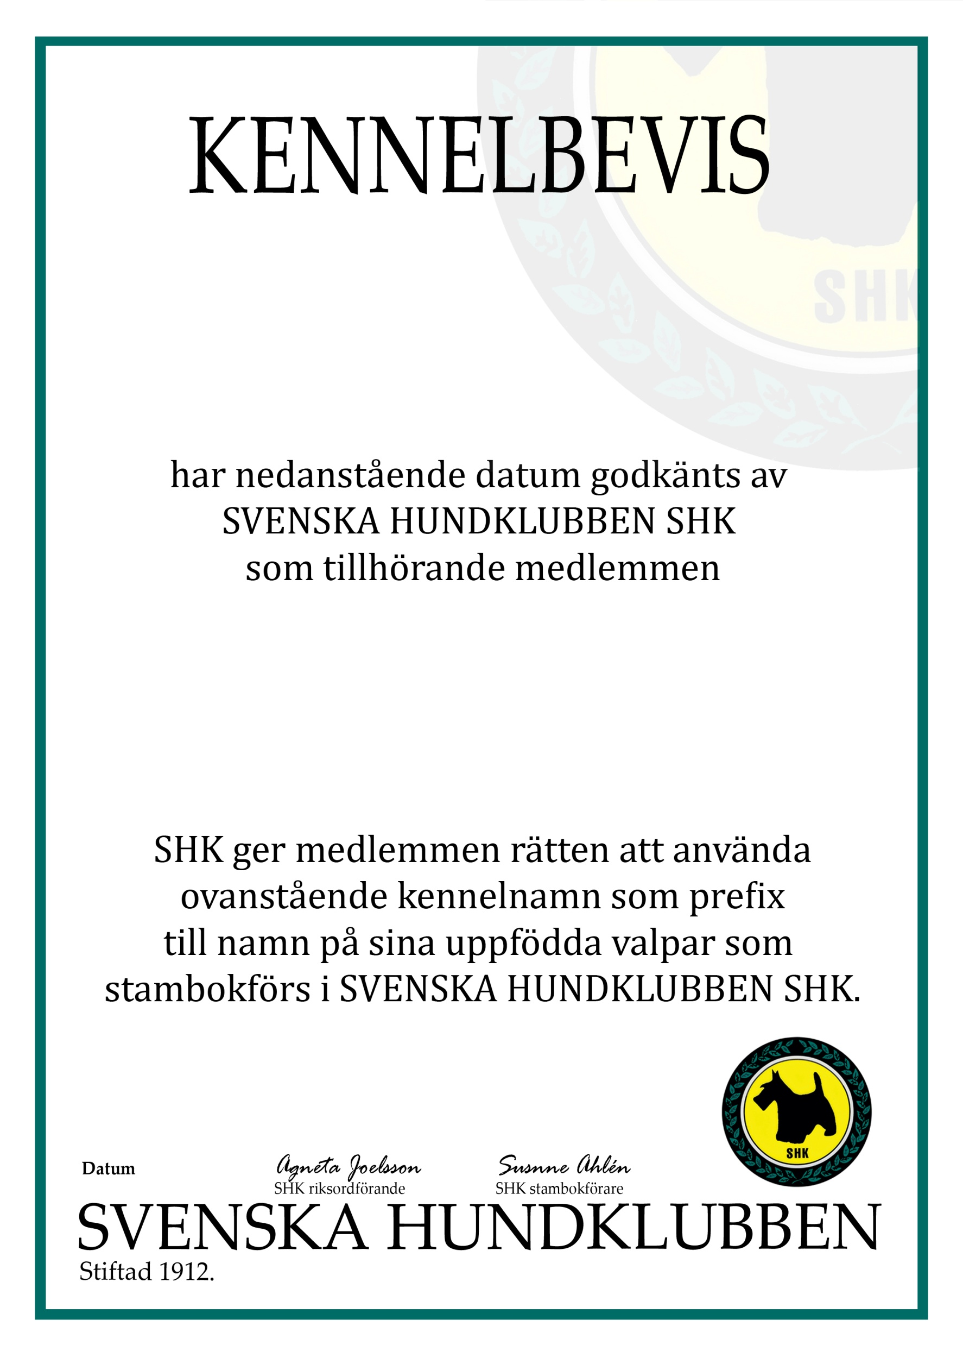

BULLAR I BOET

ELLEN ALTHÉN
19930413 8408

2026-06-10
-

